Model 1931 Carbines (Karabiner)
Year | Quantity | Serial numbers
1933 | 1193 | 520010-521202
1934 | 15534 | 521203-536736
1935 | 13664 | 536737-550400
1936 | 11326 | 550401-561727
1937 | 11639 | 561728-573366
1938 | 10344 | 573367-583700
1939 | 15300 | 583701-599000
1940 | 33575 | 599001-632575
1941 | 54150 | 632576-686725
1942 | 49350 | 686726-736075
1943 | 50475 | 736076-786550
1944 | 51900 | 786551-838450
1945 | 26200 | 838451-864650
1946 | 15600 | 864651-880250
1947 | 20950 | 880251-901200
1948 | 20100 | 901201-921300
1949 | 15500 | 921301-936800
1950 | 13200 | 936801-950000
1951 | 23050 | 950001-973050
1952 | 21400 | 973051-994450
1953 | 5549  7450 | 994451-999999  215001-222450
1954 | 17150 | 222451-239600
1955 | 11250 | 239601-250850
1956 | 6400 | 250851-257250
1957 | 2950 | 257251-260200
1958 | 3130 | 260201-263330

Model 1931 Carbines - Private series
Year |  | Quantity | Serial numbers
1934 |  | 16 | ?
1935 |  | 500 | 400001-400500
1936 |  | 100 Zoll | 401001-401100
1937 |  | 150 Zoll  200 | 401101-401250  400501-400700
1938 |  | 150 | 400701-400850
1939 |  | 20 | 401501-401520
1940 |  | 150  530  50  50 | 400851-401000  401521-402050  402151-402220  402251-402300
1941 |  | 300 | 402301-402600
1942 |  | 650 | 402501[sic]-403150[sic]
1943 |  | 350 | 403151-403500
1944 |  | 400 | 403501-403900
1945 |  | 600 | 403901-404500
1946 |  | 837 | 404501-405337
1947 |  | 929  30 | 405322[sic]-406250  E519767-E519796
1948 |  | 400 | 406251-406650
1949 |  | 650 | 406651-407300
1950 |  | 400  50 | 407301-407700  408001-408050
1951 |  | 300  50 | 407701-408000  408051-408100
1952 |  | 300 | 408101-408400
1953 |  | 450  50 | 408401-408850  409051-409100
1954 |  | 200  100 | 408851-409050  409101-409200
1955 |  | 450  100 | 409201-409650  410151-410250
1956 |  | 450 | 409651-410100
1957 |  | 50  300 | 410101-410150  410251-410550
1958 |  | 475 | 410551-411025
1959 |  | 425 | 411026-411450
1960 |  | 300 | 411451-411750
1961 |  | 300 | 411751-412050
1962 |  | 400 | 412051-412450
1963 |  | 50  400 | 267331-267380  412451-412850
1968-1969 |  | 150 | various numbers
1971 |  | 150  50 | 269431-269580  269881-269930
Stand (?) 1972 |  | 250 | various numbers
Model 1931 serial number allocation, valid after November 1, 1952
Serial numbers | Allocation
215001-350000 | K31 Carbine series, ordered by KTA for KMV
350001-400000 | K31 Carbine series
P400001-P450000 | Private K31 Carbine series
450001-500000 | K31 Carbines with telescopic sights (sniper versions)
500001-500200 | Trials versions
E519701-E519900 | Various special K31s
519901-519999 | Cutaway K31s (running backwards?), last number 519970
520001-520150 | Carbine series ordered by KTA, delivered by W+F for special purposes
520081-520100 | Ditto, reserved for W+F
520151-999999 | Carbine series, ordered by KTA for KMV
after 550651 | Hardened magazine boxes
after 540001 | Hardened receivers
The K31 Carbine
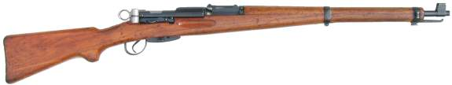
Barrel Length - 25.65 inches: 4-groove, RH, concentric rifling, 1 in 10.63
Overall Length - 43.6 inches
Weight - 8.85lbs empty
Action - Straight Pull Bolt Action
Caliber - 7.5x55 Swiss (GP11)
Capacity - 6 round detachable box magazine
Sights - Tangent-leaf sight graduated to 1500m
Total Production - 528,230
Bayonet: Models 1899/18, 1918, 1918/55 and 1914 Pioneer (Sawback)
While externally similar to the 1911 Carbine, the action of the K31 was both simpler and stronger. The bolt was shorter, which allowed for a longer barrel and a longer sight radius without significantly increasing the overall length of the rifle. Additionally, the locking lugs were once again repositioned, this time to allow the bolt to lock into the receiver ring. The shorter bolt also allowed for faster operation of the action. The K31 was adopted in 1933 and replaced all previous rifles and carbines. The K31 stayed in front line service until 1958, when it was replaced by the Stgw57. K31s were still found with some Swiss Military units, well into the 1970s. The total production run was 528,230 carbines, beginning in 1933 and ceasing in 1958 .
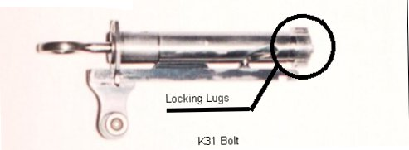

The ZfK31/42 and /43
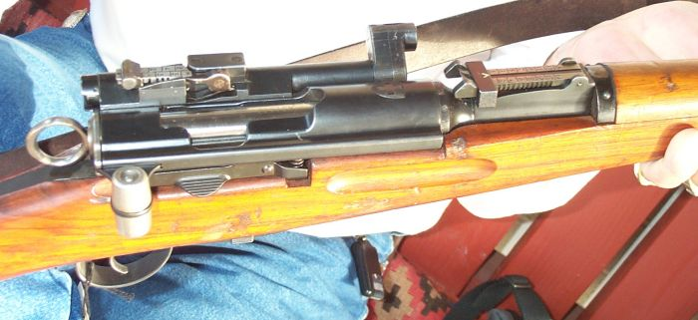
A close-up view of a K31/43's receiver and scope
Barrel Length - 25.65 inches: 4-groove, RH, concentric rifling, 1 in 10.63
Overall Length - 43.7 inches
Weight - 9.41lbs empty
Action - Straight Pull Bolt Action
Caliber - 7.5x55 Swiss (GP11)
Capacity - 6 round detachable box magazine
Sights - Optical: (Model 31/42) 1.8x optical sight (Model 31/43) 2.8x optical sight
- Iron: 2 Tangent-leaf sights One on the scope graduated to 700m and nne on the
barrel graduated to 1500m
Total Production - 2241
Bayonet: Models 1899/18, 1918, 1918/55 and 1914 Pioneer (Sawback)
The Swiss began experimenting with scope rifles in 1918. However, it wasn't until 1940, that they found a satisfactory scope. The Swiss liked the low mounted Kern scope, as it helped keep the shooters head down, thus limiting his exposure to enemy fire. The scope was mounted to the left side of slightly modified K31's. In addition to the optics, a short range (700m) iron sight was mounted on top of the scope. The K31/42 was fitted with a 1.8x sight, while the 31/43 was fitted with an improved 2.8x sight. Both scope had a rather unique periscope arrangement which allowed the Objective of scope to be rotated out of the way, when not in use. However, neither scope proved to have enough magnification or field of vision to be especially useful, and production was ceased shortly after it began.
http://www.swissrifles.com/sr/english_k11_k31_manual.pdf

Swiss Rifle Markings
Inspector's Marks
 | Major Schmidt 1864-1874
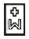 | Major Werdmüller 1875-1879
 | Major Vogelsang 1879-1912
 | Major Mühlemann 1913-1941
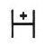 | Major Hauri 1942 -1946
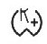 | Waffenfabrik Bern Inspection mark. Formerly referred to as a "Post 1946" mark. It now appears Waffenfabrik Bern began using this stamp in the 1942-1943 time period.
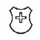 | Stamp on the Buttstock
Proof and Acceptance/Rejection Marks
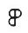 | Pressure Proof test passed
 | Shooting test passed
 | Acceptance mark for small metal parts (Vetterli)
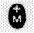 | Acceptance mark for large metal part (Vetterli)
 | Acceptance mark for large metal parts, raised (Vetterli)
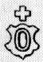 | Acceptance mark for wooden parts (Vetterli)
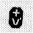 | Federal acceptance mark (Vetterli)
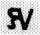 | Federal rejection mark (Vetterli)
 | Rejection mark for metal parts (Vetterli)
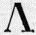 | Rejection mark for wooden parts (Vetterli)
Manufacture's Marks
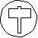 | Hammerli
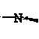 | SIG (Sometimes represented by just a N)
Other Markings
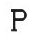
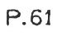 | These marking were added when the soldier elected to keep his firearm upon his retirement.
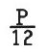
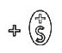 | Material certification stamps
Denote receiver made from Chrome Nickel. A +CM marking denotes receiver
made from Chrome Molybdenum.
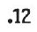
 | Stamps indicating the year repairs were made
 | found on tang, behind the receiver - indicates year rifle was refurbished at Waffenfabrik Bern.
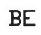 | found on tang, behind the receiver - stamp by Canton Arsenal
 | found on tang, behind the receiver - stamp indicates a repair was made
 | Canton Arsenal stamp
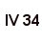 | Found under the buttplate - indicates month and year of stock manufacture
Other Markings
Rifle Markings
AB = Amsler und Blank Schaffhausen
ALz = Affolter und Lenk Zürich
A+B = Amsler und Blank Schaffhausen
AK = Adolf Knapp Rheinfelden
BS = Burri, Schmid und Compangie Luzern
WA = Wahl und Aemmer Basel
W&A= Wahl und Aemmer Basel
C = Cordier und Compagnie Bellefontaine
ET = von Erlach und Compagnie Thun
F&S = Freuler und Sohn Glarus
GI = Gamma und Inganger Altdorf
PH = Peter Haenni Sitten
VS = Valentin Sauerbrei Basel
S.BS = Valentin Sauerbrei Basel
AZ = A. Zoller Frauenfeld
R.T = Jean Ruckstuhl Töss
GSW = Gebrüder Sulzer Winterthur
ThK = Th. Klaus Genf
S&W = Socin und Wick Basel
SW = Socin und Wick Basel
EWy = Escher-Wyss und Compagnie Zürich
WvS = W. von Steiger Thun, vormals von Erlach
MST = Markus Steiger Thun
FG = Fabrique des armes Genève
Cb = Camenzind Bouchs
SL = Seiler Liestal
MT = Meili Trogen
MO = Johann Mundwiler Olten
Hä = Hämmerli Lenzburg
KB = Kaspar Bösch St. Gallen
B&B = Buholzer und Burri Luzern
B+B = Buholzer und Burri Luzern
SG = J.J. Schläpfer Glarus
J = M. Jaquet Genève
LKa = Leonhard Kästli Altdorf
LK = Leonhard Kästli Altdorf
Ms = J. Müller und Sohn Bern
JKW = Johann Konrad Walser Trogen
WS = Walty-Scheurmann Schöftland
HO = Hans Ochsenbein Basel
WSo = Wüthrich Solothurn
Cantonal markings:
AG (or CA)= Canton Aargau
AI = Appenzeller Innerrhoden
AR = Appenzeller Ausserrhoden
BE = Bern
BL = Canton Basel
BS = Basel City
CF = Canton Freiburg
CG = Kanton Glarus
CGL (or GL)= Canton Glarus
CL = Canton Luzern
CN = Canton Neuenburg
CTh=Canton Thurgau
CV = Canton Vaud
CZ = Canton Zürich
F (or FR) = Freiburg
GE = Geneva
GR = Graubünden
JU = Jura
KA= Kanton Aargau
KG = Kanton Glarus
KL = Kanton Luzern
KN = Kanton Neuenburg
NE= Neuchâtel
NW = Nibwalden
OW = Obwalden
SH = Schaffhausen
SO = Solothurn
St.G (or SG) = St.Gallen
SZ = Schwyz
TH = Thurgau
TI = Ticino
UR = Uri
VD = Vaud
VS = Valias
ZG = Zug
ZZ = Zeughaus Zürich
Other short codes:
PE = (57PE by example) Privat Einzelschuss
W+F = Eidgenössische Waffenfabrik Bern
W+K = Waffenkontrolle
TA = Technische Abteilung
MFT = Munitionsfabrik Thun
MFA = Munitionsfabrik Altdorf
KMV = Kriegsmaterialverwaltung
SIG = Schweizerische Industriegesellschaft Neuhausen
Inspection markings:
W = Inspektor Werdmüller
V = Inspektor Vogelsang
M = Inspektor Mechel oder Inpektor Müller oder Insp. Mühlemann
G = Inspektor Grunauer
L = Inspektor Ledermann
O = Inspektor Oertle
S = Inspektor Schenk
E = Inspektor Ehrsam oder Egger
Sc = Inspektor Schläppi
Hs = Inspektor Hubschmidt
R = Inspektor Reymann
Ny = Inspektor Nydegger
T = Inspektor Tanner oder Thurnysen
H = Inspektor Hauri

