The K31 Carbine
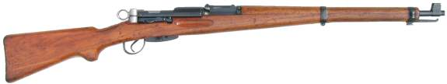
Barrel Length - 25.65 inches: 4-groove, RH, concentric rifling, 1 in 10.63
Overall Length - 43.6 inches
Weight - 8.85lbs empty
Action - Straight Pull Bolt Action
Caliber - 7.5x55 Swiss (GP11)
Capacity - 6 round detachable box magazine
Sights - Tangent-leaf sight graduated to 1500m
Total Production - 528,230
Bayonet: Models 1899/18, 1918, 1918/55 and 1914 Pioneer (Sawback)
By the end of the 1920s the Swiss began to question whether or not they should equip their soldiers with rifles or carbines. Indeed, 2/5th of the Infantry and 3/5th of the rest of the army were already equipped with carbines rather than long rifles. While the rifles provide better accuracy and range, the carbines were lighter and easier to handle. Interestingly enough, while the carbines accuracy was considered adequate for military purposes, it was the member of the various private Swiss shooting clubs that were insisting the more accurate rifle be kept in service.
In 1928, first attempt at combining the positive qualities of the rifle and carbine was made by fitting a K11 with a heavy barrel. 200 heavy barreled carbines were produced and tested. However, the gains in accuracy were outweighed by the added cost of the weapon. The decision was made in April 1929 that a new design for the carbine.
The following requirements were set for the new weapon
- The new weapon should not be significantly longer than the 1911 Carbine.
- The new weapon should have a straight-pull action
- The new weapon should be more accurate than the 1911 Carbine, and as accurate as the 1911 Rifle
- The new weapon should be cheaper to produce than the 1911 series.
Testing began in late 1929 and continued into 1930 of two prototype designs, and end with favorable results. In late 1930 10 new design carbines were sent to the shooting school in Wallenstadt for evaluation. The new design carbine’s accuracy was compared with that of the 1911 Rifle and the heavy barreled carbine. The results of the testing showed the new design carbine to be more accurate than either the rifle or the heavy barrel carbine. However, there were some design issues that needed addressing.
In May 1931, a series of 200 improved carbines were produced. These carbines were issued to various shooting schools as well as six recruit schools. The testing continued until October 12, and produced the following conclusions:
- The new bolt design was less prone to binding.
- There were fewer feed problem.
- The new action was less prone to failure, even in the event of one of the locking lugs breaking.
- The new stronger action was better able to survive firing with a barrel blockage.
- The new designs proved very durable, four carbines had 150,000 rounds fired through them without any appreciable failures.
Unlike the previous Schmidt-Rubin series of rifles, the new carbine’s locking lug locked up immediately behind the chamber. This afforded several advantages. The entire action was strengthened as the lugs were locking in a much thicker part of the action. Lock-up was also more precise. The bolt was significantly shortened, allowing for a longer barrel and sight radius, without increasing the overall length of the rifle, moving the rear sight closer to the eye, and cutting in half the amount of time for the firing pin to strike the cartridge after the trigger was pulled.
The new carbine also had several other new features. The barrel was intended to be free floating. The action itself only connected to the stock by two screws, one attaching to the chamber, with the second attaching to the tang. This allowed the Swiss to eliminate the aluminum barrel collar used in the Schmidt-Rubin series. The trigger was redesigned, as were the magazine and rear sight.
The end result of these modifications produced a rifle that was more accurate, yet cheaper than the K11, it was replacing. In 1932 it was estimated that the cost of a K11 would be 169 Swiss Francs. Conversely, the new carbine had an estimated cost of 151 Swiss Francs.
On March 17, 1932, the Swiss Upper Parliament accepted the new carbine into service and designated it the Model 1931.
During it’s production run there were several minor modifications made to the K31.
1934, the firing pin was made thinner.
1935, the receiver was hardened
1936, the magazine shell was hardened
1941, laminated stocks were tested, but rejected
1944, due to supply shortages, Chromium Molybdenum was use in place of Chromium Nickel Steel on various parts. This experiment proved unsuccessful.
1946, starting with serial number 868,901, beech rather than walnut was used for making the stocks.
The K31 stayed in front line service until 1958, when it was replaced by the Stgw57. K31s were still found with some Swiss Military units, well into the 1970s. The total production run was 528,230 carbines, beginning in 1933 and ceasing in 1958.
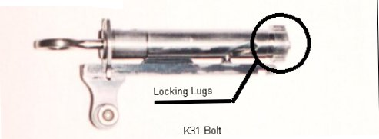

The ZfK31/42 and /43
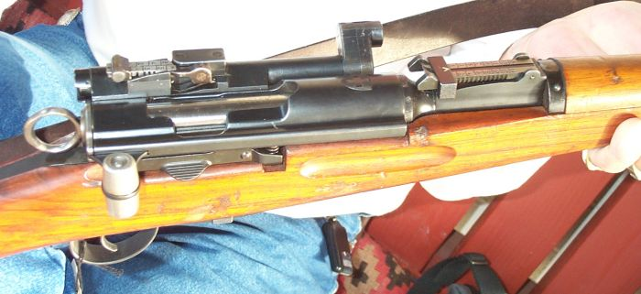
A close-up view of a K31/43's receiver and scope
Barrel Length - 25.65 inches: 4-groove, RH, concentric rifling, 1 in 10.63
Overall Length - 43.7 inches
Weight - 9.41lbs empty
Action - Straight Pull Bolt Action
Caliber - 7.5x55 Swiss (GP11)
Capacity - 6 round detachable box magazine
Sights - Optical: (Model 31/42) 1.8x optical sight (Model 31/43) 2.8x optical sight
- Iron: 2 Tangent-leaf sights One on the scope graduated to 700m and nne on the
barrel graduated to 1500m
Total Production - 2241
Bayonet: Models 1899/18, 1918, 1918/55 and 1914 Pioneer (Sawback)
The Swiss began experimenting with scope rifles in 1918. However, it wasn't until 1940, that they found a satisfactory scope. The Swiss liked the low mounted Kern scope, as it helped keep the shooters head down, thus limiting his exposure to enemy fire. The scope was mounted to the left side of slightly modified K31's. In addition to the optics, a short range (700m) iron sight was mounted on top of the scope. The K31/42 was fitted with a 1.8x sight, while the 31/43 was fitted with an improved 2.8x sight. Both scope had a rather unique periscope arrangement which allowed the Objective of scope to be rotated out of the way, when not in use. However, neither scope proved to have enough magnification or field of vision to be especially useful, and production was ceased shortly after it began.
The ZfK55 Sniper Rifle
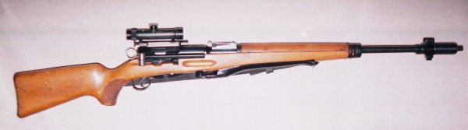
Barrel Length - 25.65 inches: 4-groove, RH, concentric rifling, 1 in 10.63
Overall Length - 47.55 inches
Weight - 13.5lbs empty (with scope attached)
Action - Straight Pull Bolt Action
Caliber - 7.5x55 Swiss (GP11)
Capacity - 6 round detachable box magazine
Sights - Tangent-leaf sight graduated to 1500m
Total Production - 4150
Bayonet: Models 1899/18, 1918, 1918/55 and 1914 Pioneer (Sawback)
For addtional detailed photos go to the ZfK55 Sniper Rifle Photo Gallery
While the ZfK55 possess many visual similarities to the K31, the two rifles only have four parts in common (the cocking piece, the firing pin, the firing pin spring, and the extractor.) The ZfK55 is fitted with a 3.5x scope mounted to the left of the receiver, with the mounts being an integral part of the receiver. The entire action of the ZfK55 is tilted at an angle to allow for ejecting cartridges to clear the scope. The barrel fitted to the ZfK55 is heavier than the one one the K31 and is fitted with a large muzzle-brake/flash suppressor. The ZfK55 also boasts a half-stock with a pistol grip and a bipod.

