Most are listed here:
community.webshots.com/al...LRpCgxkBqC
Page_____Type____Distance_____Height/click_______Windage/click
5, a______Furter___100-500m____2cm at 300m______2cm at 300m
6, b______Grünel___300m________5cm at 300m_____5cm at 300m
7, c______Sahli_____300m_______2cm at 300m______None
7, d______Tip Tip___300m_______2.5cm at 300m_____None
8, e______Hämmerli__300m_______None____________3cm at 300m
8, f______Girex_____300m_______4-5cm at 300m____None
9, g______Hofmann_300m_______6cm/shim at 300m__None
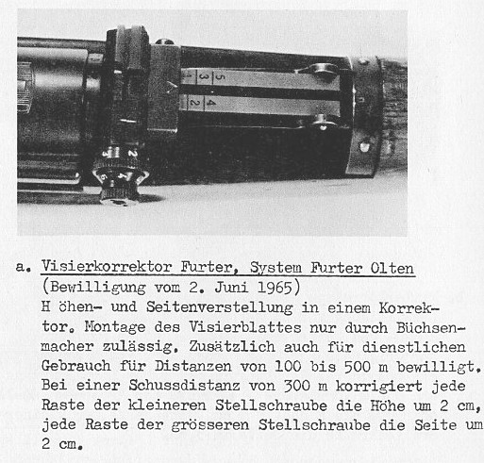
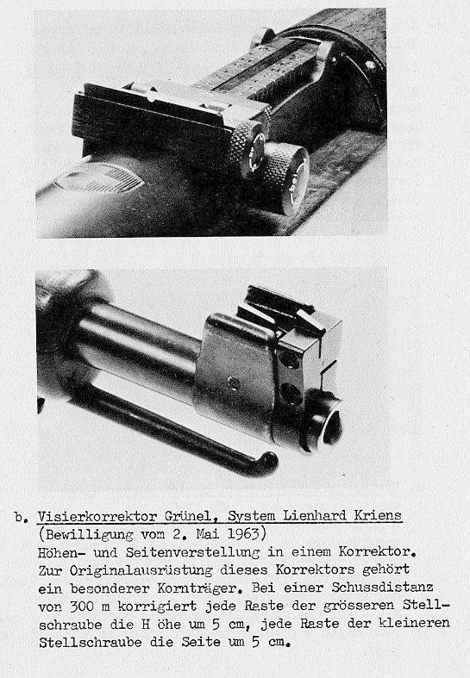
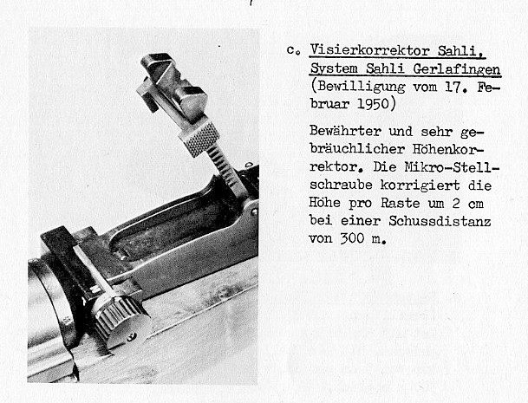
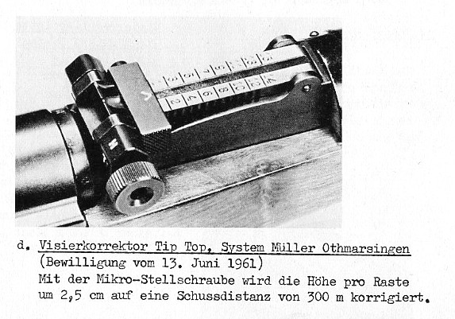
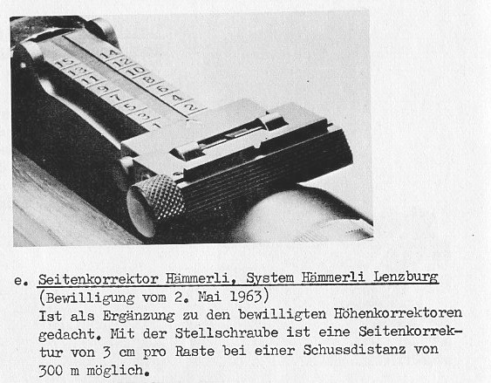
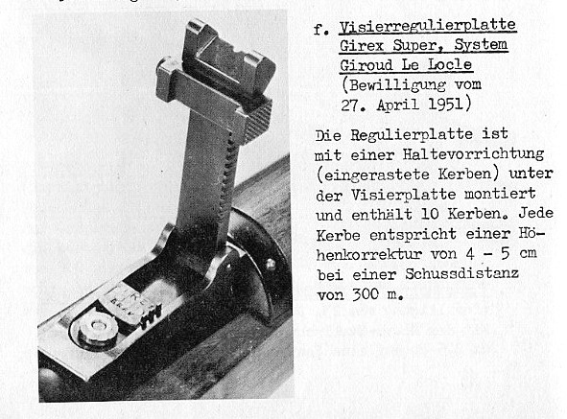
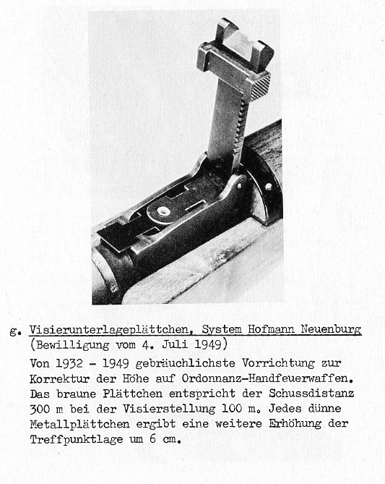
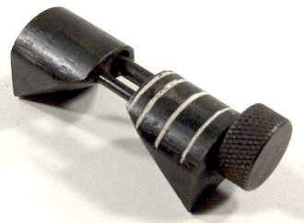
Unknown, K-31 elevation only.
